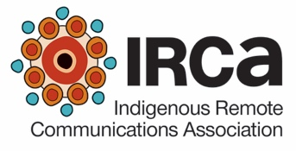
Indigenous Remote Communications Association
Board of Directors Nomination Seconding Form

This form is provided for the purposes of streamlining the seconding process for Board of Director positions. The seconding organisation must be a current Ordinary Member. This form may be sent direct to IRCA after completing all details below.

SECONDING A NOMINATION FOR IRCA DIRECTOR

Name of person nominated
Organisation making the primary nomination

NOMINATION
SECONDER (Nominations may only be made by Ordinary Members)
I second the nomination of the person whose name appears above for the position of Director on the IRCA Board. (Please add the seconder details in the following fields)
Name of the Ordinary Member Representative seconding the nomination (the Seconder)
Name of the Ordinary Member’s organisation
Contact email for Seconder

Contact phone number for Seconder
Signature of Ordinary Member Representative (the seconding nominator)
Date

Send the completed nomination form (email, fax or mail) to:
Jennifer Nixon
Contact Person, Indigenous Remote Communications Association
PO Box 2731
ALICE SPRINGS NT 0871
E asstmgr@irca.net.au Fax 08 8992 9669
This form must be received at IRCA by 5pm (Central Standard Time) 26 April 2017. No late nominations will be accepted.

